# OTF-1200X-Openable Cover High Temperature Vacuum Tube Furnace

**Standard Operation Procedure**

1. Displays

LED Indicators

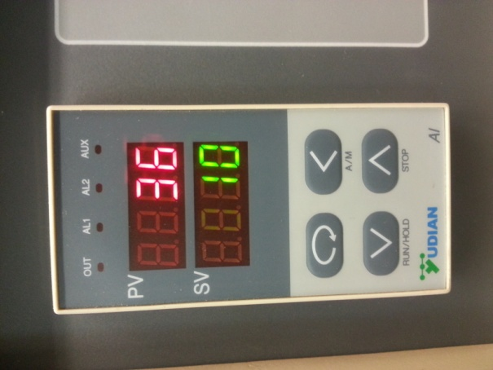

Data Increase Key

Data Shift Key

Process Value (PV)

Setup Key

Data Decrease Key

Set Point Value (SV)

Figure 1: "Home" screen display of Yudian 708P temperature controller with sections annotated.

* 1. Description of Display Sections
     1. Process Value (PV) –displays the process value, “actual temperature”, or parameter code
     2. Set Point Value (SV) –displays the set point value, “desired temperature”, current operation such as Stop, Run, or Hold
     3. 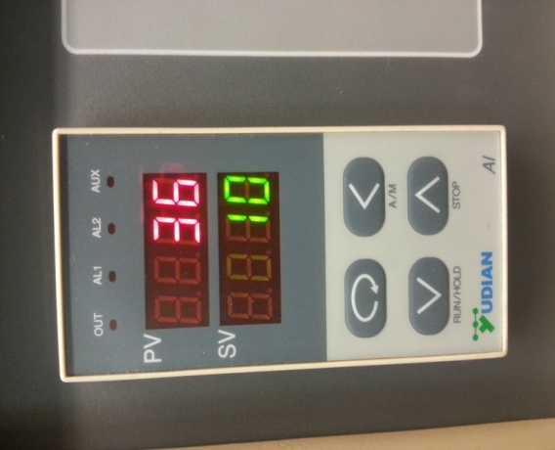 Setup Key: –for accessing parameter table and confirming

parameter modifications

* + 1. 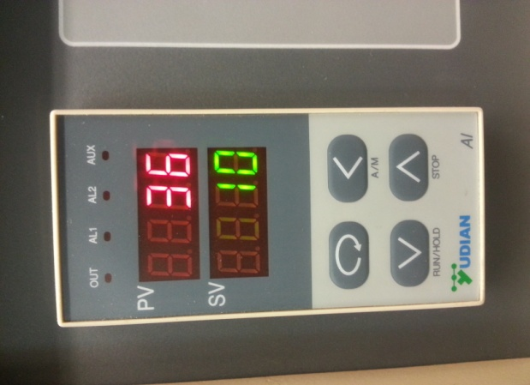 Data Shift Key –allows user to change the numbers place that is

being manipulated, when pressed from the “Home” screen accesses the parameter table

* + 1. 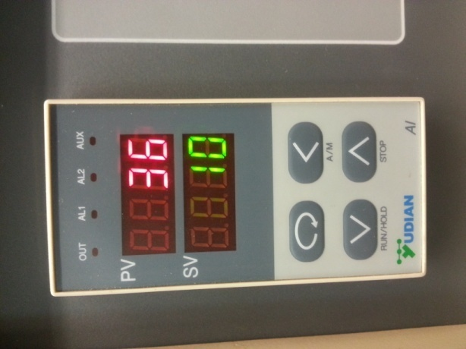 Data Decrease Key–allows user to decrease value, also when held

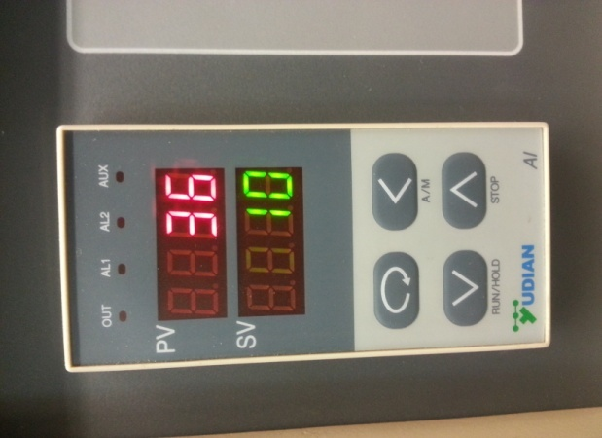 for ~2 seconds allows for the operation to begin (Run) or be paused (Hold)

* + 1. Data Increase Key –allows user to increase value, also when held

for ~2 seconds allows for the operation to stopped (Stop)

* 1. Common Key Operations
     1. 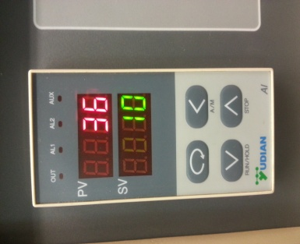To enter the parameter table from the “Home” screen press **Data Shift Key .**
     2. 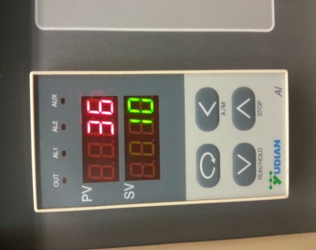When in the parameter table, to confirm a parameter value and cycle to the next press **Setup Key .**
     3. 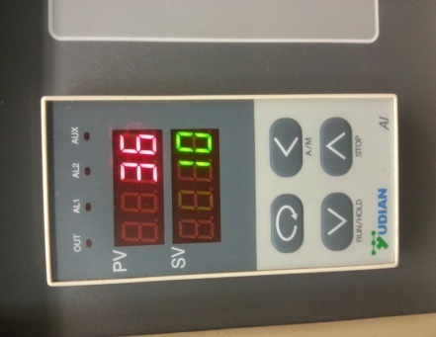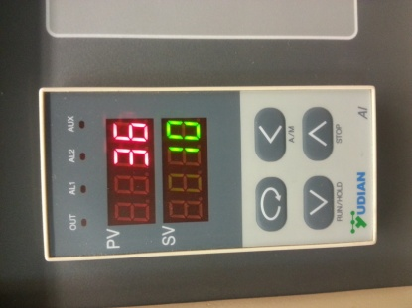To exit the parameter table once needed value has been set press and hold **Data Shift Key** followed by **Setup Key .**
     4. 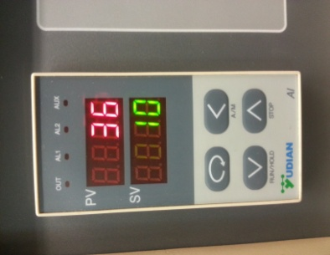To start or pause a program press and hold **Data Decrease Key .**

1. Operation Setup

To illustrate how to enter in the process parameters, an example of a typical heat treatment is given in Figure 2 and corresponding input values are presented in Table 1. It is recommended that a similar scheme be prepared prior to using the furnace.

Figure 2: Temperature profile for the heat treatment of Ni 200 with critical points denoted a-g.

|  |  |  |  |  |
| --- | --- | --- | --- | --- |
| **Step** | **Symbol in PV** | **Input Value** | **Description:** | **Corresponding points on Figure 2** |
| 1 | C 01 | 0 | Initial Temperature | a |
| 2 | t 01 | 50 | Ramp time from 0 to 400°C (Rate: 8°C/min) | a to b |
| 3 | C 02 | 400 | Target Temperature for first heating (400°C) | b |
| 4 | t 02 | 100 | Dwell time of 100 min at 400°C | b to c |
| 5 | C 03 | 400 | Temperature at end of first heating stage (400°C) | c |
| 6 | t 03 | 100 | Ramping time from 400 to 1000°C (Rate: 6°C/min | c to d |
| 7 | C 04 | 1000 | Target Temperature for second heating stage (1000°C) | d |
| 8 | t 04 | 100 | Dwell time of 100 min at 1000°C | d to e |
| 9 | C 05 | 1000 | Temperature at end of second heating stage (1000°C) | e |
| 10 | t 05 | 50 | Ramping time from 1000 to 200°C | e to f |
| 11 | C 06 | 200 | Target temperature for cooling stage | f |
| 12 | t 06 | -121 | Program End, Output off. Air cool. | f to g |

Table 1 was prepared to correspond to the heat treatment profile in Figure 2 and to the parameter table in the Yudian software. Do not exceed a ramp rate of 10°C/min.

1. Operation
   1. Prepare a parameter table similar to Table 1. **Make sure that the maximum ramp rate does not exceed 10°C/min.**
   2. Turn on the furnace power by turning the **Lock** switch clockwise. The Yudian temperature controller should turn on and you should see Figure 3 with SV flashing **Stop.**

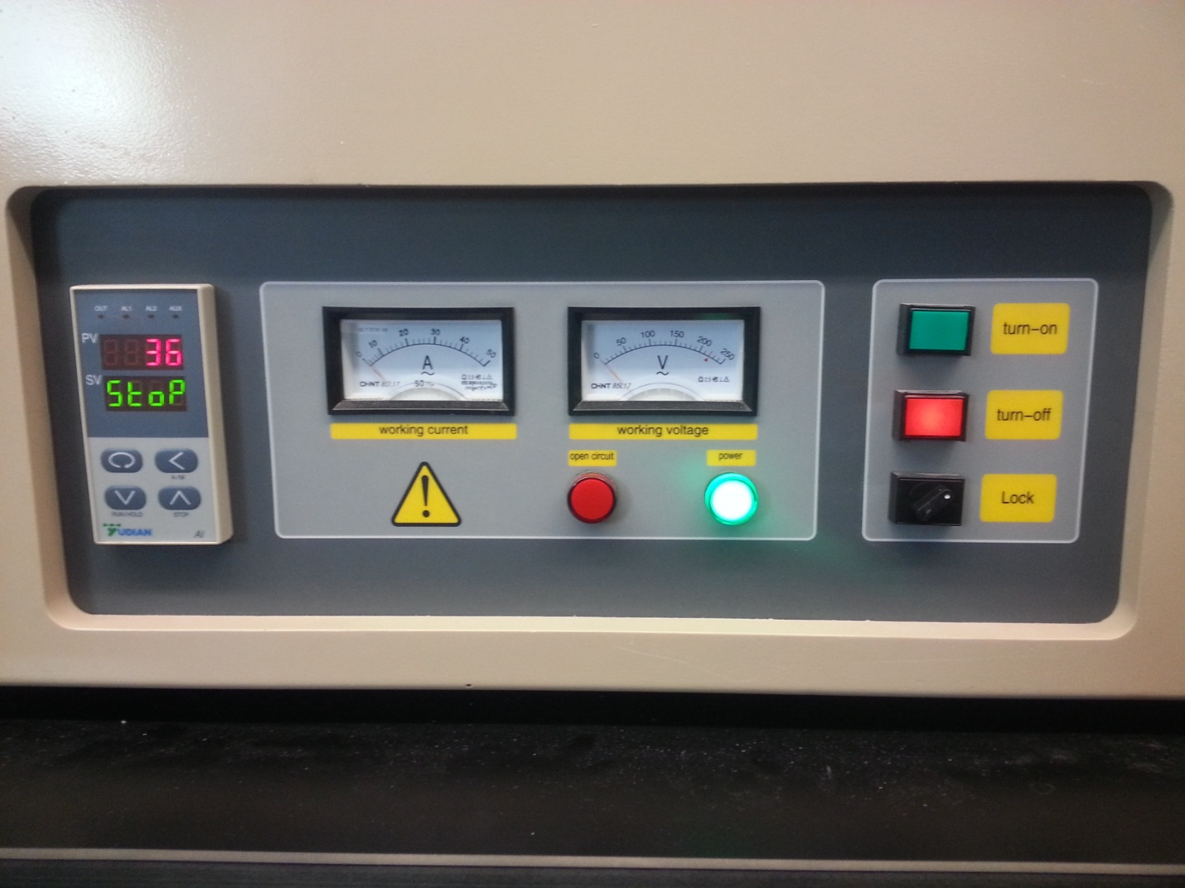

Figure 3: Main control cluster for MTI-OTF-1200X Tube Furnace.

* 1. 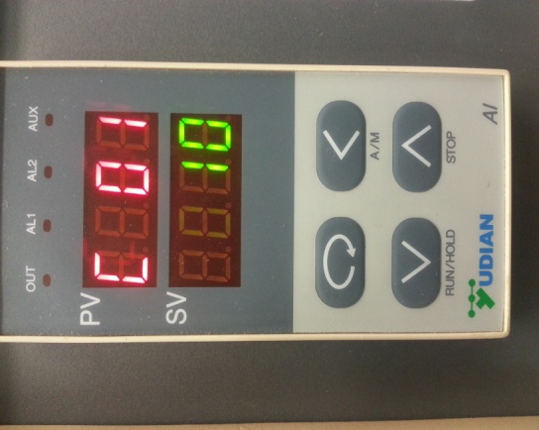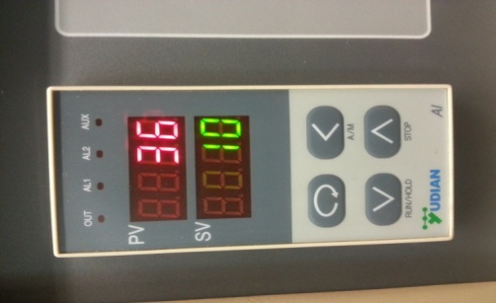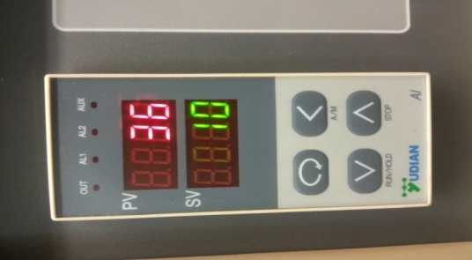To enter the parameter table from the “Home” screen press Data Shift Key . A screen similar to Figure 4 should be seen.
  2. Use the and keys to adjust the set point value for the initial temperature (**C 01 = 10**).
  3. Once the initial temperature is set, press to cycle to the next parameter, (**t 01**). Set **t 01** according to your parameter table. Again press to cycle to the next parameter.

Figure 4: Initial screen of the parameter table.

* 1. Continue to enter in parameters according to your parameter table using the steps above. The last **t xx** parameter should be set to -121 which sends the command to stop the temperature controller.
  2. Once all parameters have been entered, **either** press and hold followed by to exit the parameter table, **or** turn the **Lock** switch counter-clockwise (to turn the furnace off) and then clockwise (to get back to the “Home” screen).
  3. 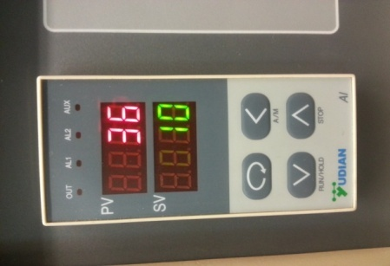Starting with **Step c** double check that all parameters are set correctly.
  4. 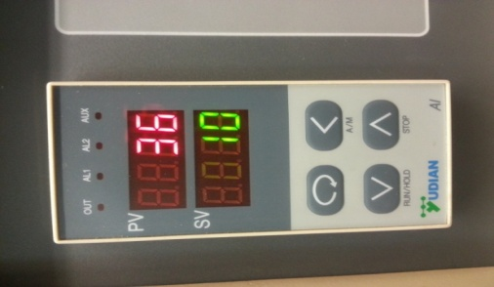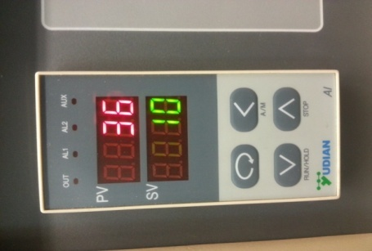To start the controller program entered, press and hold until SV read **run**. If at any time the program needs paused, press and hold until SV reads **hold**. This causes the program to pause and remain at the set point value shown.
  5. To stop the program at any time press and hold until SV reads **Stop**. This stops the program and turns off power to the heating coils.
  6. Once the program has ended and the furnace is at a reasonable temperature to air cool (~400°C), the red **turn-off** button may be pushed and the **Lock** switch may be turned counter-clockwise.

NOTES:

1. Do not exceed a ramp rate of 10°C/min.
2. Do not exceed 1150°C.
3. Set up a parameter table to aid in the programming process.
4. **txx=-121** is a command to end the program.
5. If the furnace has not been used recently, preheat the furnace at 200°C for at least 2 hours to remove moisture and avoid cracking of the tube.
6. To maintain a uniform temperature zone and protect the vacuum gaskets, use the two alumina end blocks.
7. If you have any questions, ask for assistance.